Virtusa React Training

B Sahil (221910304005)

Day 9

**React component life cycle**

It has 3 phases:

Mounting – creating a component class.

Updating - adding data

Unmounting – deleting data

With related to each and every phase, it contains some predefined methods. Each method will be meant for performing a specific task.

**React Hooks**

In the functional component, some of the functionalities of class component will not be performed. In order to perform the functionalities of class component in functional component, we have React Hooks. Some of the Hooks are

useState, useEffect, useError.

Example –

useEffect-

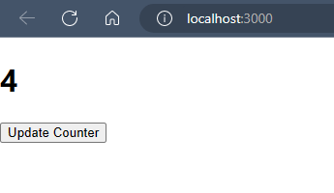

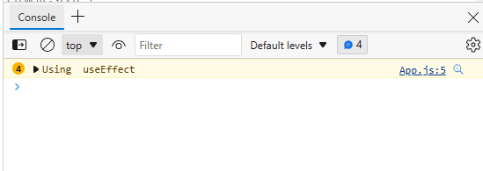

App.js

import React from 'react'

import { useState , useEffect } from 'react';

export default function App() {

    const[count,setCount]=useState(0);

    useEffect(()=>{console.warn("Using  useEffect")})

    return(

    <div className="App">

    <h1>{count}</h1>

    <button onClick={()=>setCount(count+1)}>Update Counter</button>

    </div>

    );

}